1. Write a program to Print Fibonacci Series using recursion.

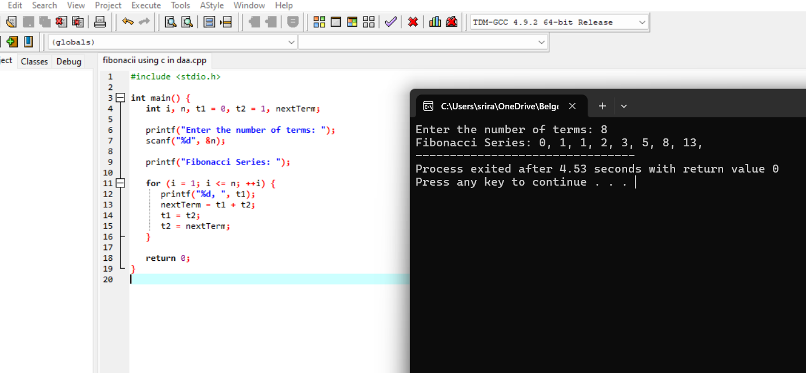

1. Write a program to check the given no is Armstrong or not using recursive function.

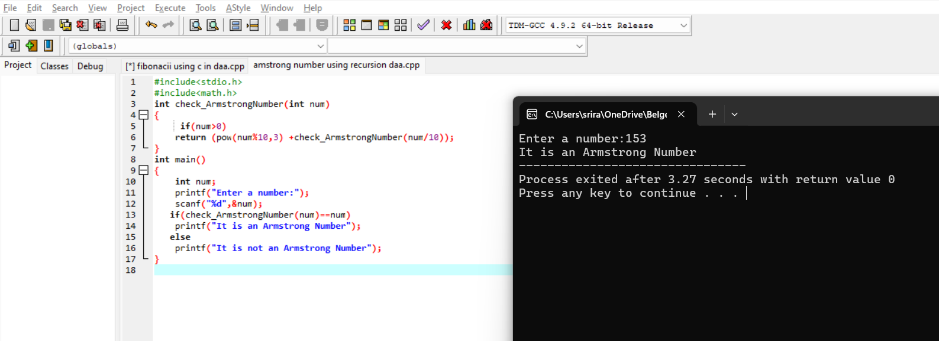

1. Write a program to find the GCD of two numbers using recursive factorization.

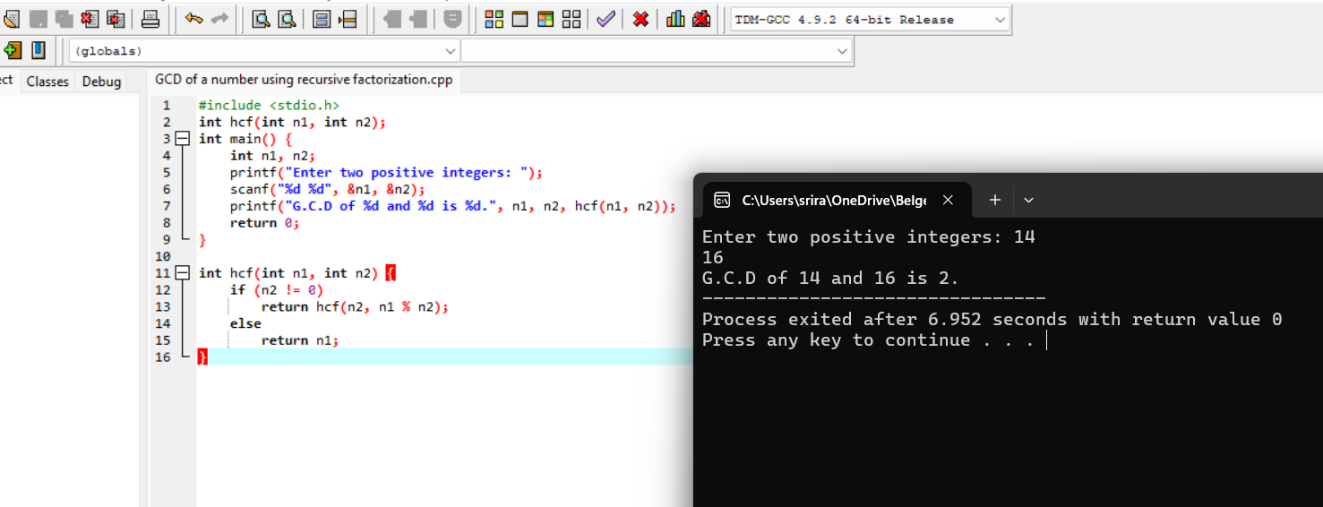

1. Write a program to get the largest element of an array.

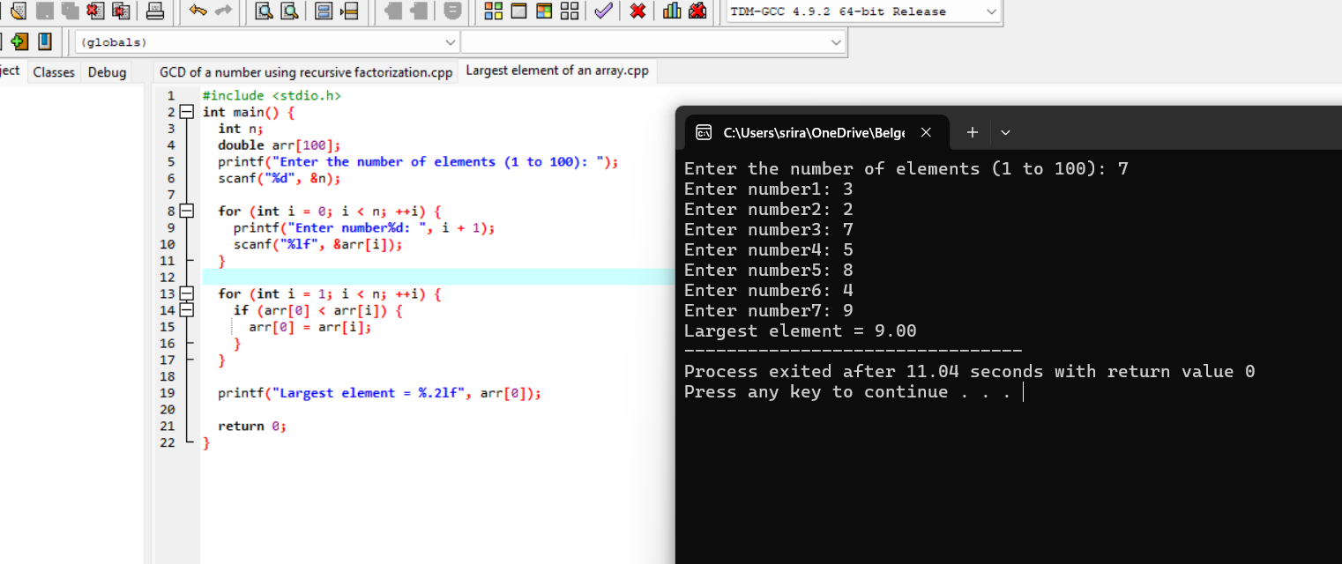

1. Write a program to find the Factorial of a number using recursion.

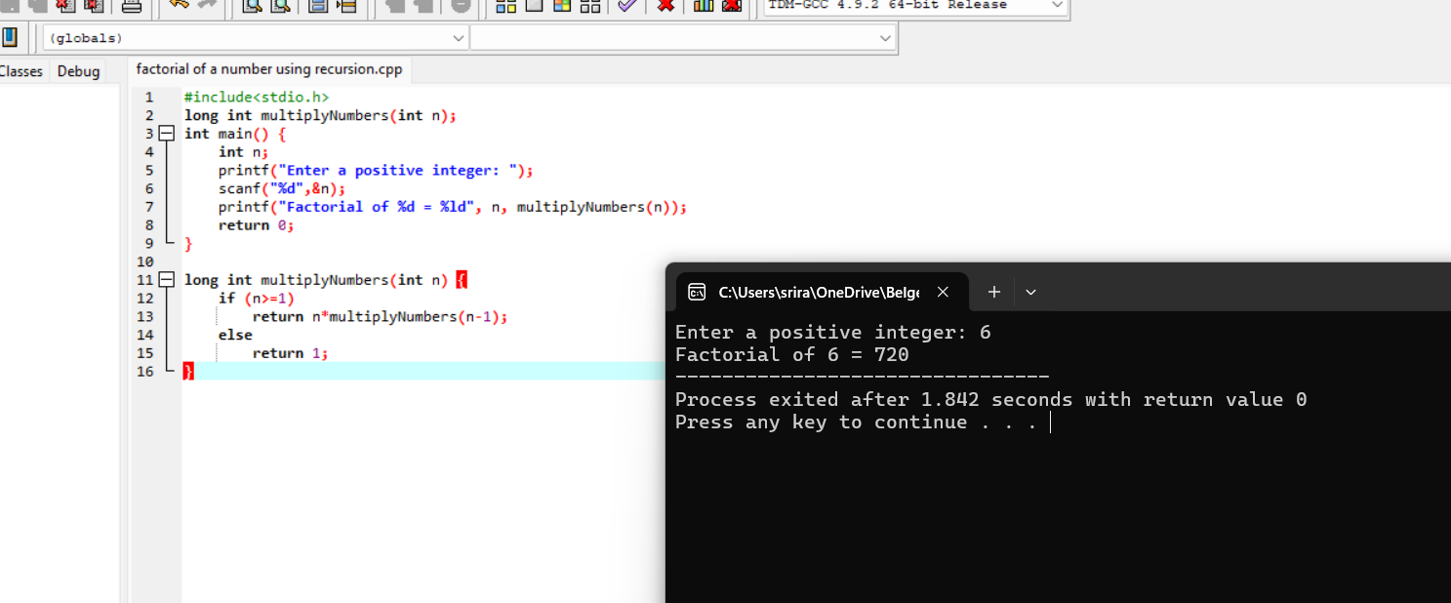

1. Write a program for to copy one string to another using recursion.

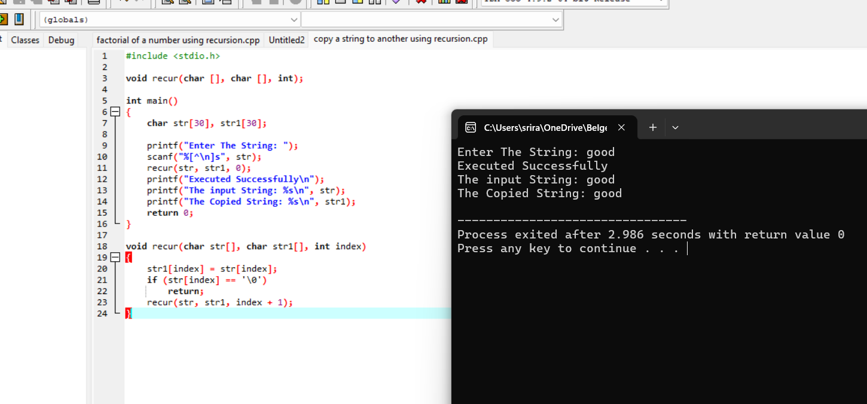

7. . Write a program to print the reverse of a string using recursion.

